Schedule 1 – Statutory Declaration Template

LETTERHEAD OF COMPANY
Please copy this letter on the letterhead of your company

STATUTORY DECLARATION

To The European Money Markets Institute - subscriptions@emmi-benchmarks.eu

Subject: Statutory declaration on data usage

_____________________ [Place, Date]

____________________________________ [Name of company] declares that during the calendar year_____________________, it has used _____________________ [number] of Single Screen Subscriptions and/or Medium-size country Subscription the details of which are as follows:

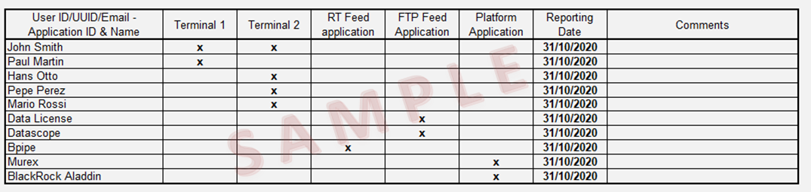

Signature of company’s authorised representative:

Name of company’s authorised representative:

____________________________

